Elements of interior designing

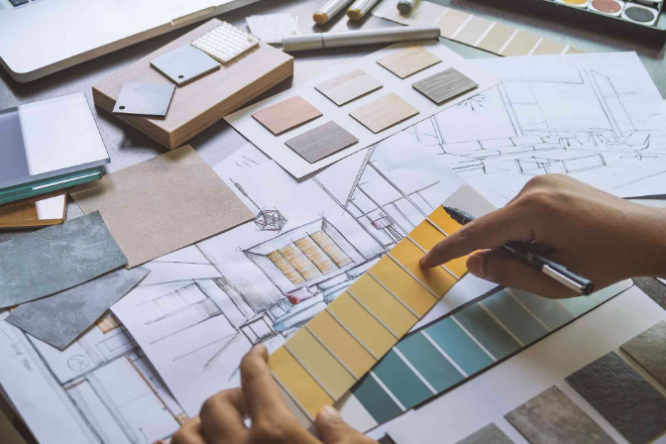

Regardless of whether you are working with existing furniture and objects or starting from scratch with an empty room, it is imperative to utilize the elements and principles of design as your guiding framework in making selections. The elements serve as your tools or raw materials, akin to the pigments for an artist. The elements of design encompass space, line, form, color, and texture. The principles of design pertain to how you employ these elements, and include balance, emphasis, rhythm, proportion and scale, as well as harmony and unity.

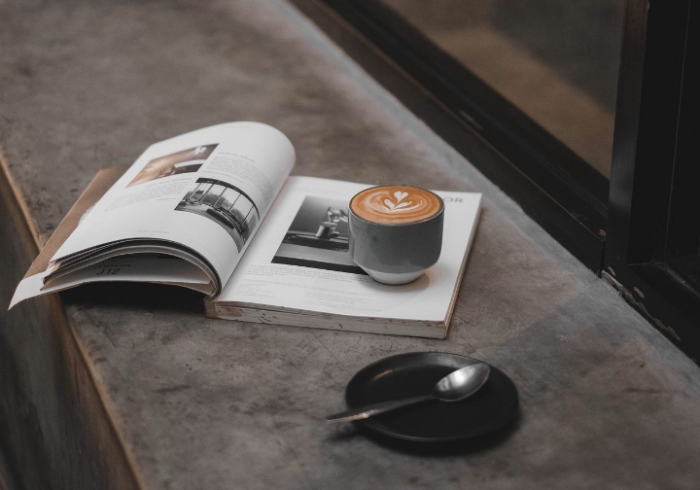

**1. Space:** Space delineates and establishes the boundaries of functional and decorative elements you may employ. Typically, you may not be defining the space; rather, you will be faced with the challenge of utilizing the existing space effectively and functionally.



**2. Line:** Lines in a room are second in significance only to color when it comes to determining the overall mood or feel of the space. The lines of windows should uphold the dominant line of the room. In most situations, the dominant line is straight (vertical, horizontal, or diagonal), rather than curved. Your choice to emphasize the direction of the lines will determine the mood you wish to create. Vertical lines add height and grandeur, establishing a more formal atmosphere. Vertical lines also balance the horizontal lines found in most furniture. Horizontal lines tend to create a calm, informal ambiance. They work well in casual rooms or as a counterpoint to the strong verticals in formal spaces. Diagonal lines draw attention and lead the eye. They can be unsettling unless supported by verticals or opposing diagonals. Curved lines impart a softening effect and shield the room from excessive rigidity. Use curved lines with a measure of restraint to prevent the room from becoming overly soft and excessively feminine.

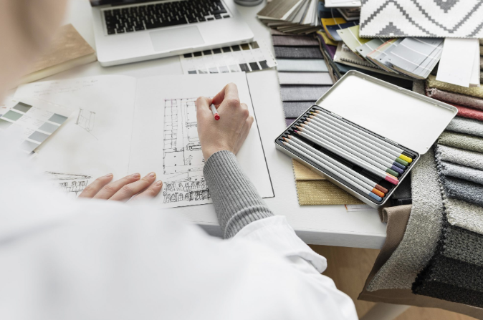

**3. Form:** The lines that converge create the shape of an object, which in turn influences the overall perception of the space. Straight lines create rectangles, squares, and triangles. Curved lines form circles and ovals. The rectangle is the most prevalent shape and often serves as the dominant form in a room. Triangles provide stability, while curved forms soften the contours of objects.

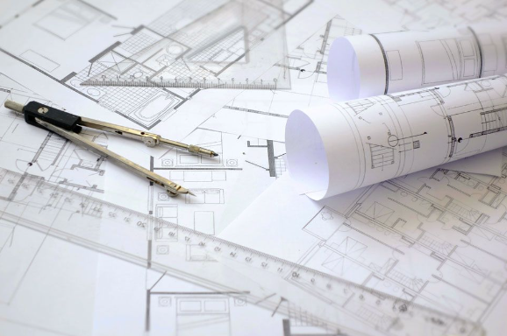

**4. Colour:** More than any other element, colour can enhance the beauty of a room. Colour has the power to set the mood. It can make a room feel warmer or cooler, larger or smaller. It can conceal unattractive features or draw attention to a focal point. Even with the simplest furniture, the judicious use of colour can transform a room.

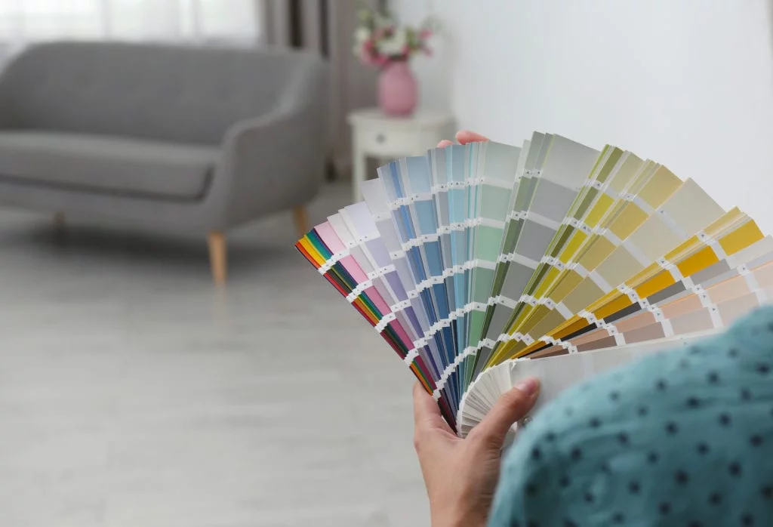

**5. Texture:** Texture plays an increasingly vital role in home decoration. Visual texture is the perceived smoothness or roughness of a material. To maintain and enhance a relaxed feel, use fabrics with a more pronounced visual texture, such as fluffy or coarse textures. Smooth, shiny surfaces like silk, satin, and polished wood maintain a more formal feel in the room. Incorporating multiple levels of complementary textures adds variety and sustains interest. However, it is advisable to avoid dramatic contrasts in texture.

